**Jenkin Automation: Working Jenkin with Command line**

1. To Work with Jenkins in Command line mode run below command. Follow below steps.
   1. Localhost:8080/cli
   2. Download the Jar which is mentioned on the URL to work on it.
   3. You will get list of all command line command which will help you

**The Jenkin Environment: Access Control**

1. Click on Jenkin Dashboard 🡪 People 🡪 Display all user name and access.
2. If your login first time on Jenkins, you have all access.
3. Go to Credential 🡪 Global Credentials
4. **Go to Configure Global Security 🡪 click on Enable Security**

**Code and Build Promotion:**

**Parameterized Builds:**  Go to **Configure 🡪 Click on “this build is parameterized”**

Put the values.

**Deployment Automation:**  We are going to deploy the java application on Tomcat apache 7 server.

We are going to use the simple script which will copy the .WAR file from workspace and paste it to tomcat/webapps folder which will automatically get deployed on Tomcat machine.

Paste the below command in Build section for **Execute Windows batch command**.

**Copy c:\Example_java_project\Calendar.war “C:\programs files\Apache Software Foundation\Tomcat 7.0\webapps”**

**Distributed Builds:**

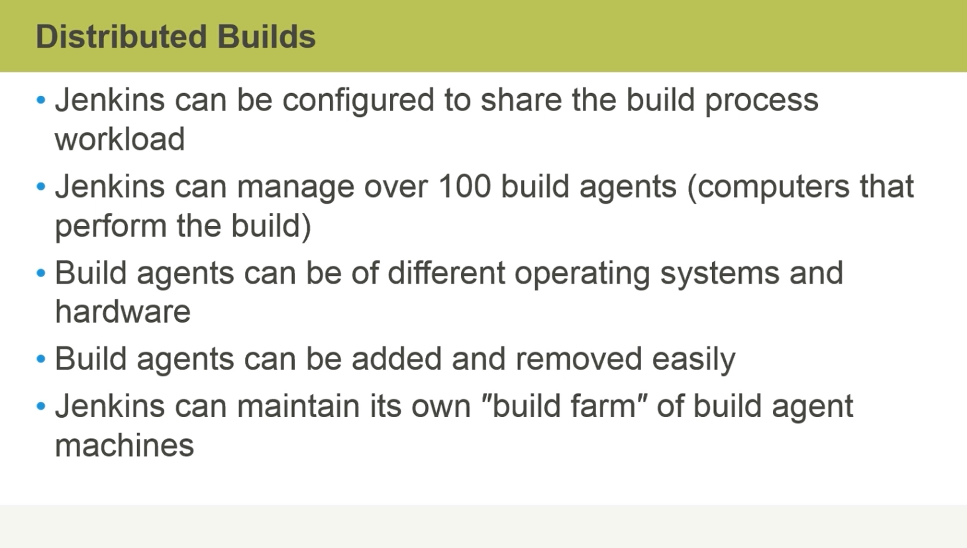

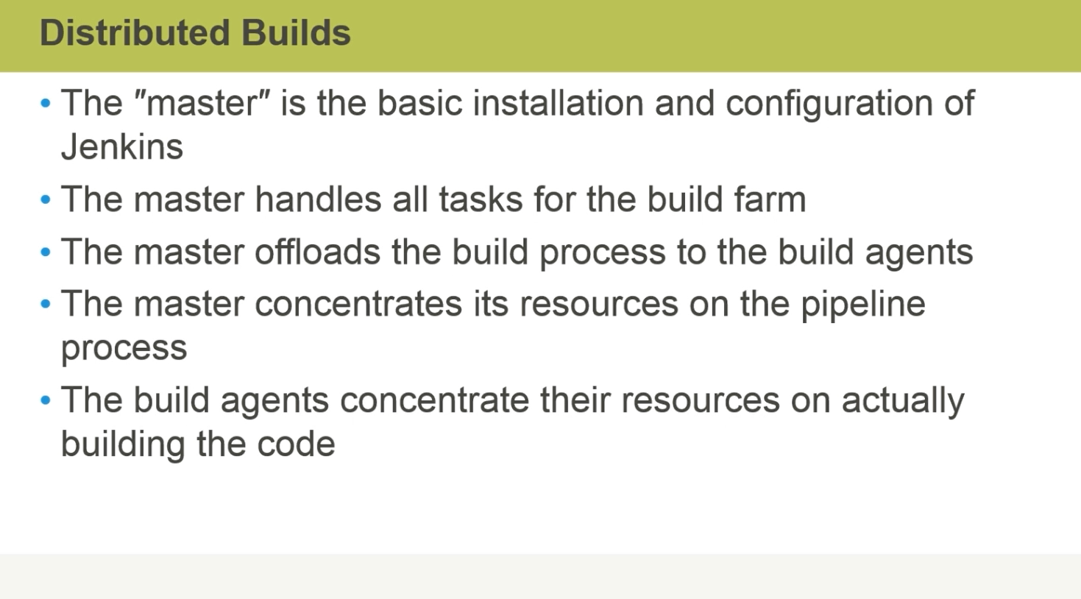

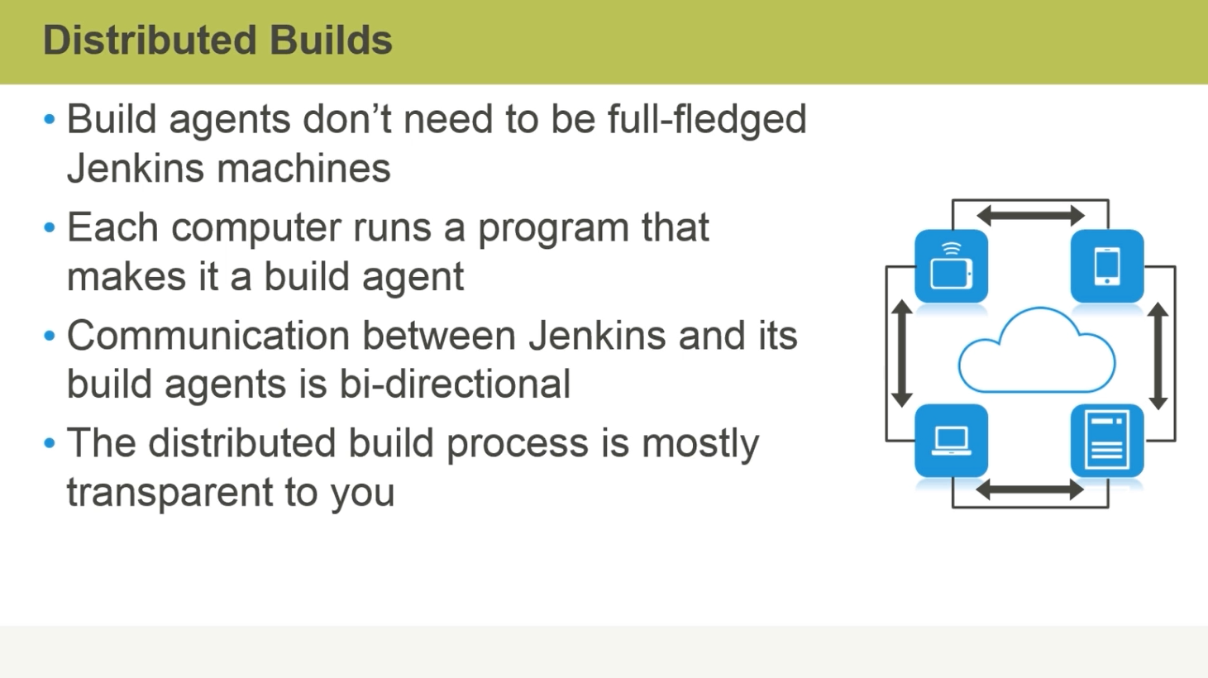

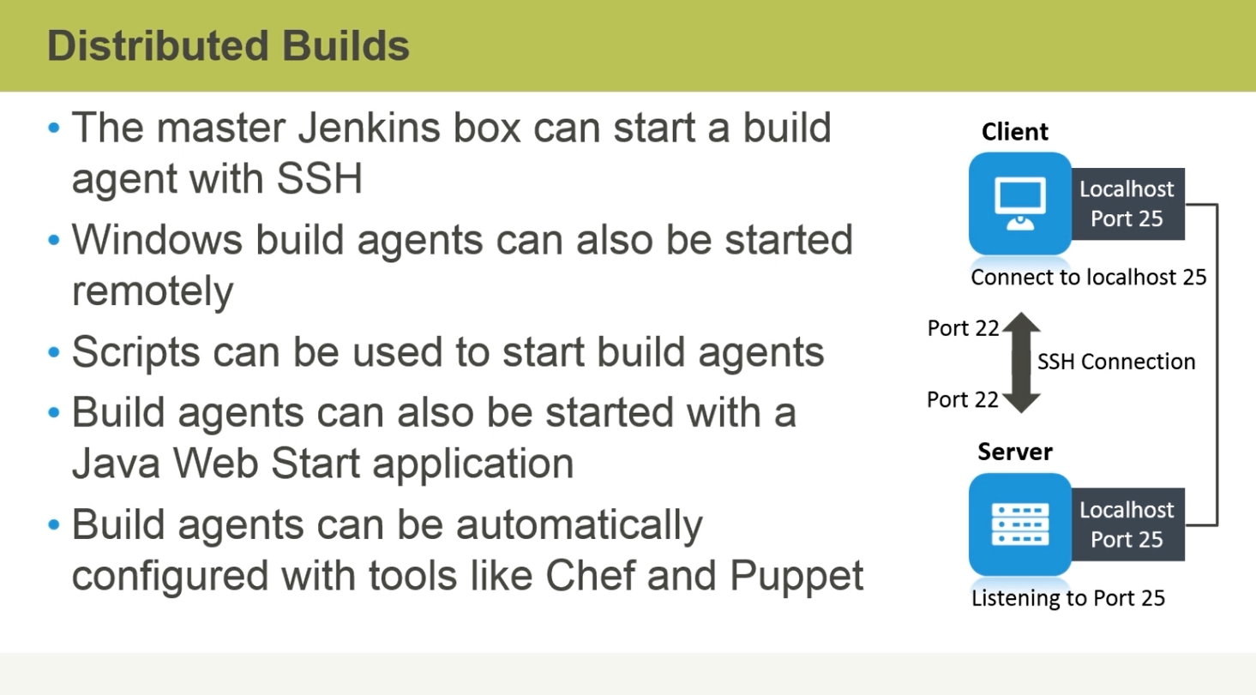

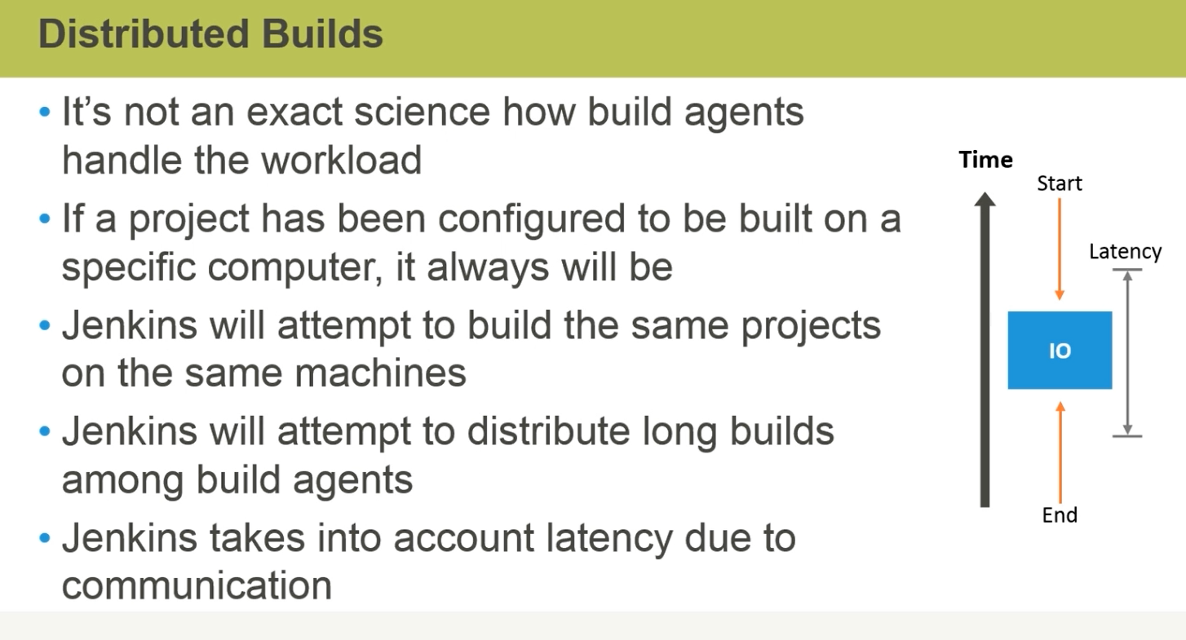

**Jenkins Jobs and Security**

1. **Different types of Jenkins Jobs.** 
   1. FreeStyle Project
   2. Maven Project
   3. External Job
   4. Multi-Configuration project
   5. Copy existing item
2. **Build Triggers:** Different ways to run the Jenkin jobs.
   1. Configure 🡪 Source Code management 🡪 Build triggers
   2. There are multiple ways to trigger a build.
      1. Build after other projects are built
      2. Build periodically
      3. Poll SCM

Check polling Log to check when the last time job run and next when it scheduled. If there is no change than it will not run.

1. **Scheduling Build Jobs:**

Click on the scheduled icon of the job.

Configure 🡪 Build Triggers 🡪 Build Periodically 🡪 type in the schedule in corn format.

Example:

***** 🡪 First 🡪 mins, Second🡪 hours , third 🡪 day of the month, fourth 🡪 month, fifth 🡪 day of the week.

*/5**** 🡪 Build will run after every 5 mins.

1. **Polling the SCM:** Mapping the GitHub with the Jenkin Jobs by using the source code management.  **It will Poll your Source code management after some time.**

Configure 🡪 Build Triggers 🡪 Poll SCM 🡪 type in the schedule In the corn format.

***** 🡪 First 🡪 mins, Second🡪 hours , third 🡪 day of the month, fourth 🡪 month, fifth 🡪 day of the week.

*/5**** 🡪 Build will run after every 5 mins.

**To check the log. Go to the Job and polling Log.**

1. **Jenkin Security Overview:**

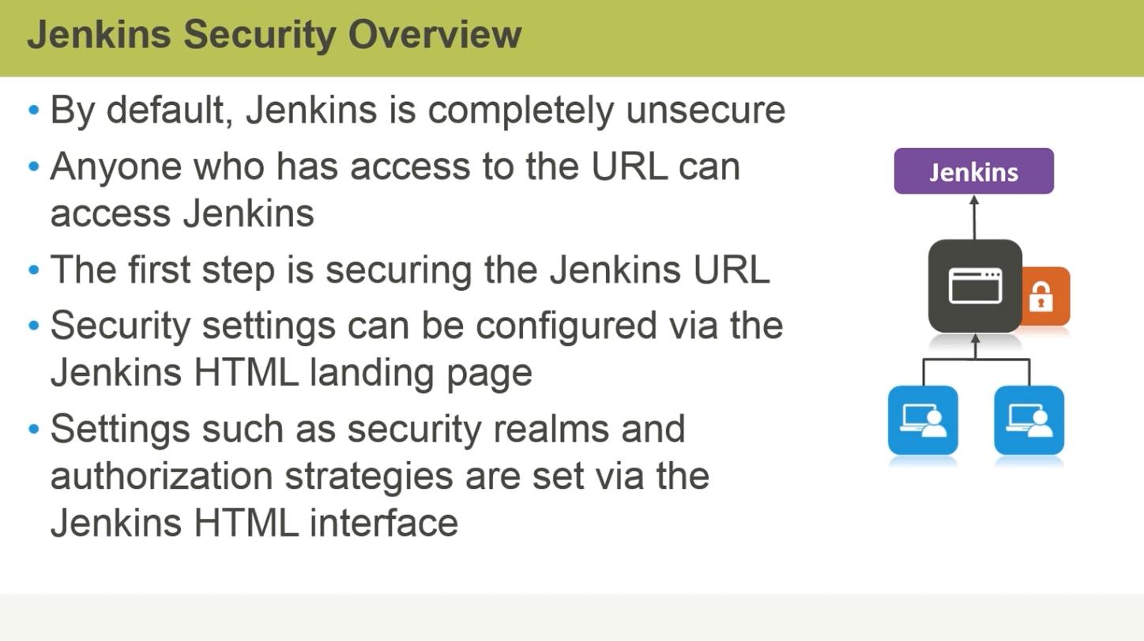

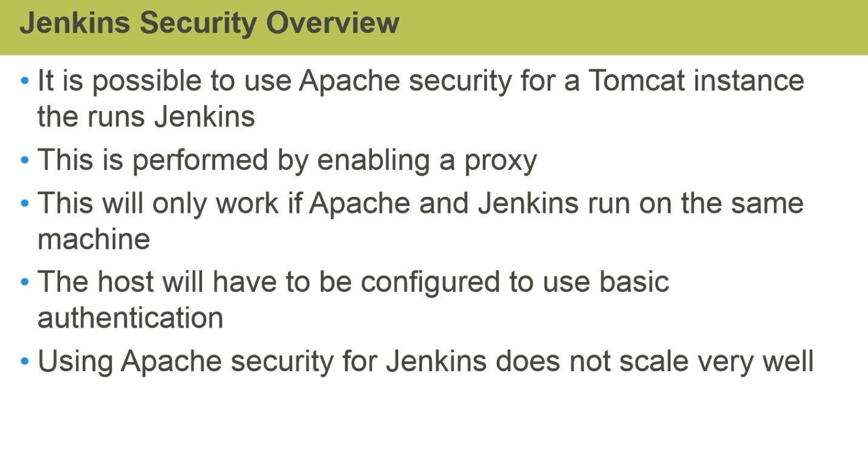

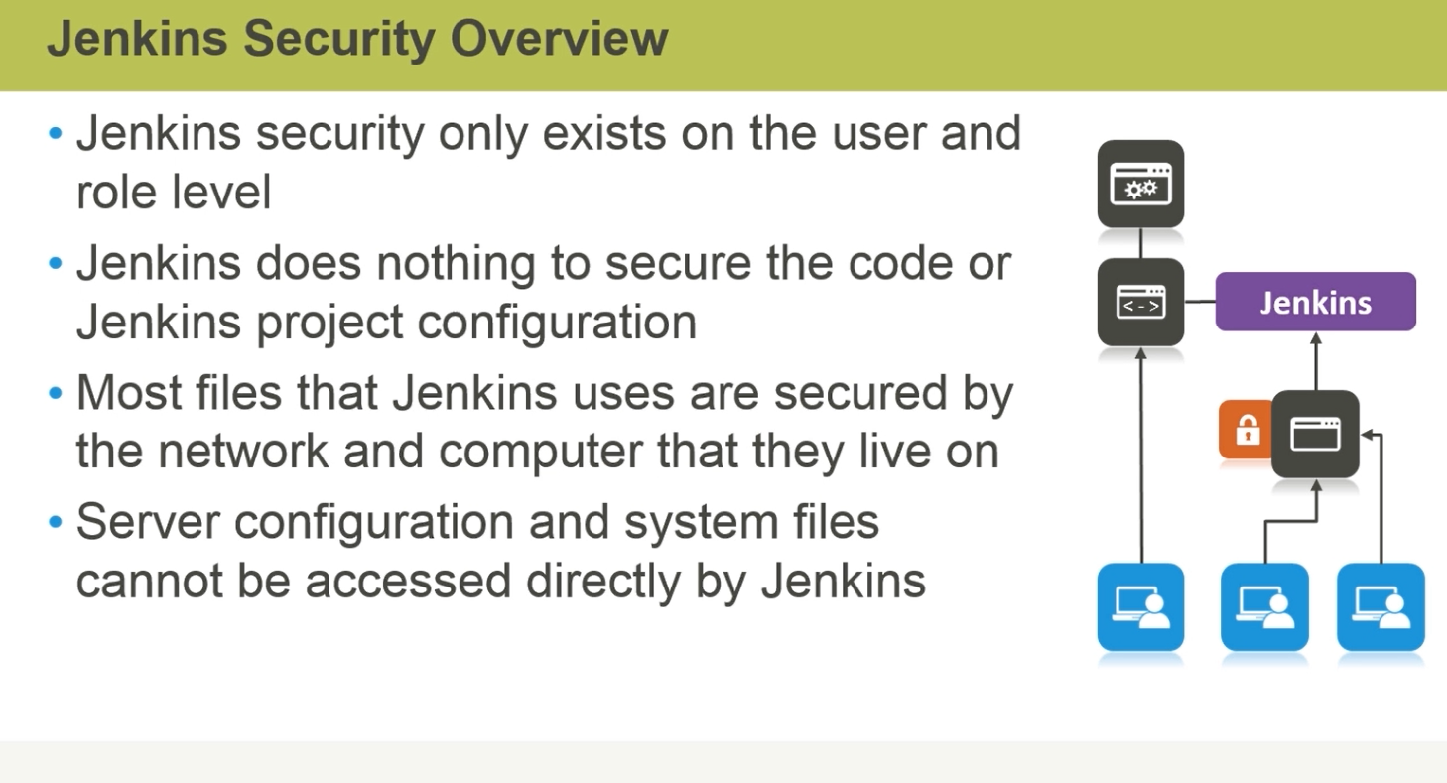

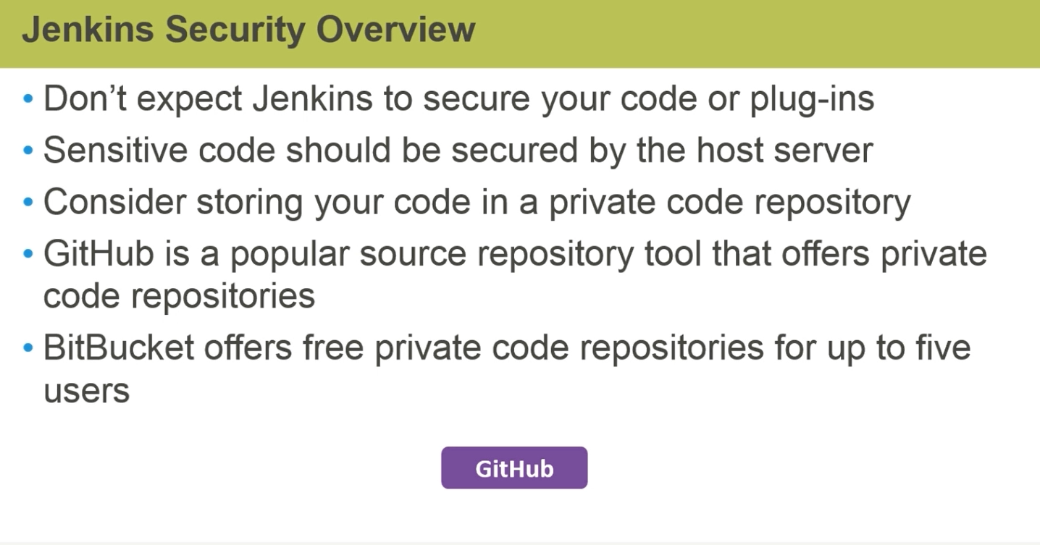

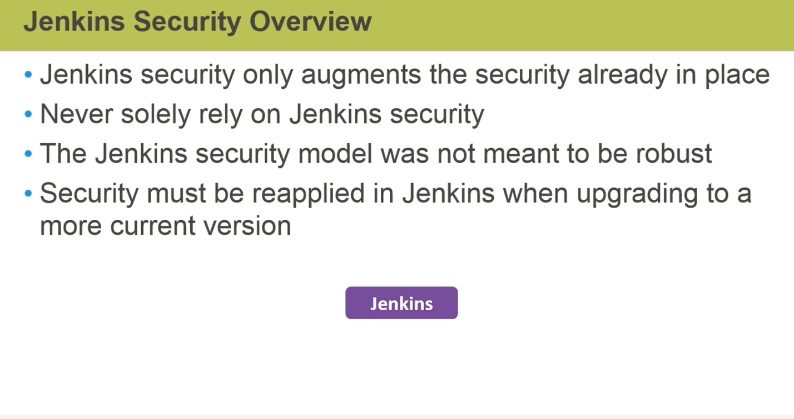

1. **Authentication:**

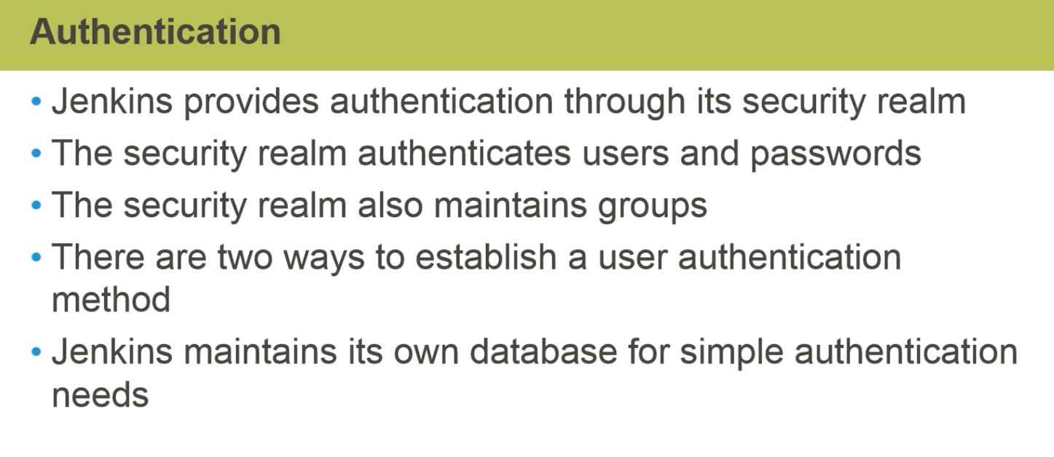

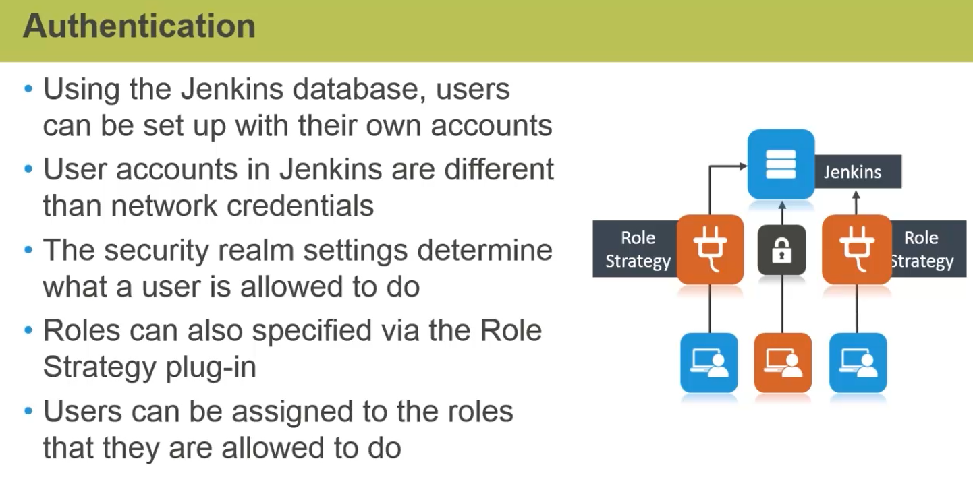

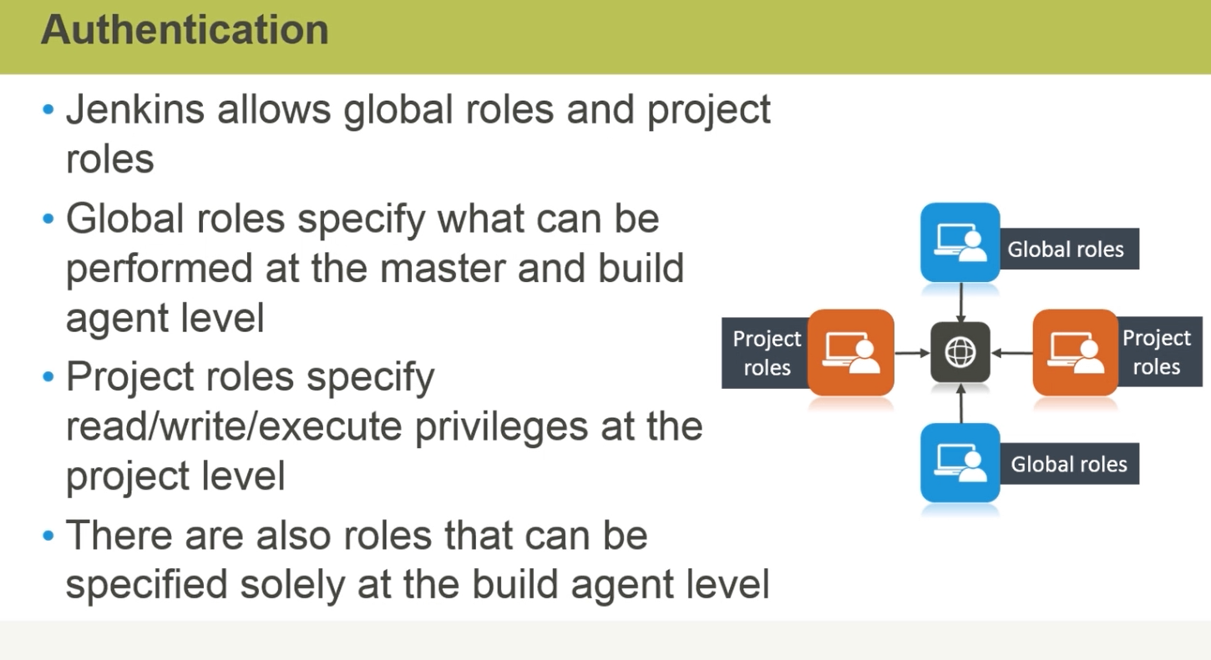

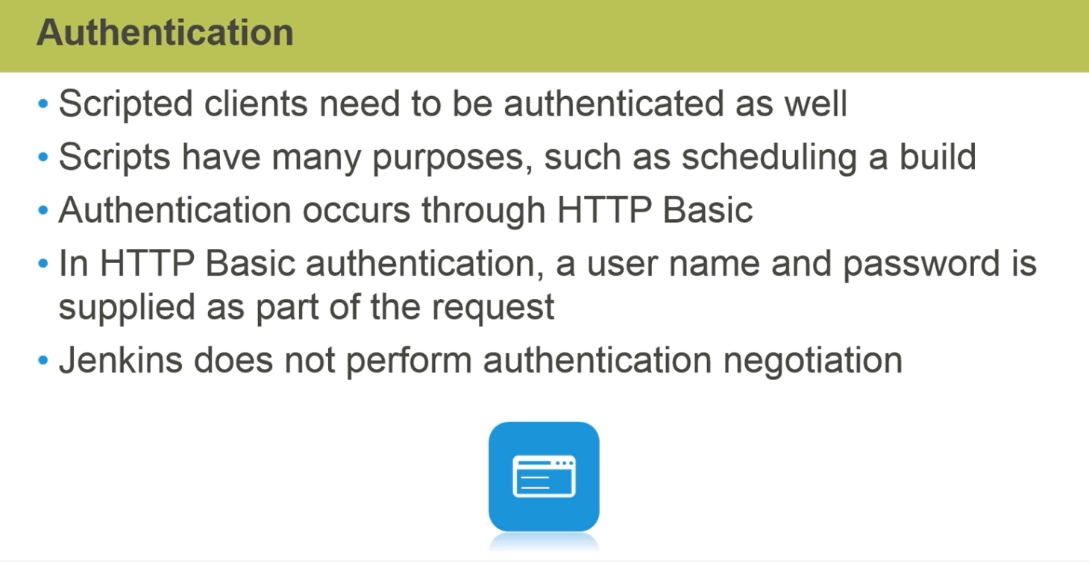

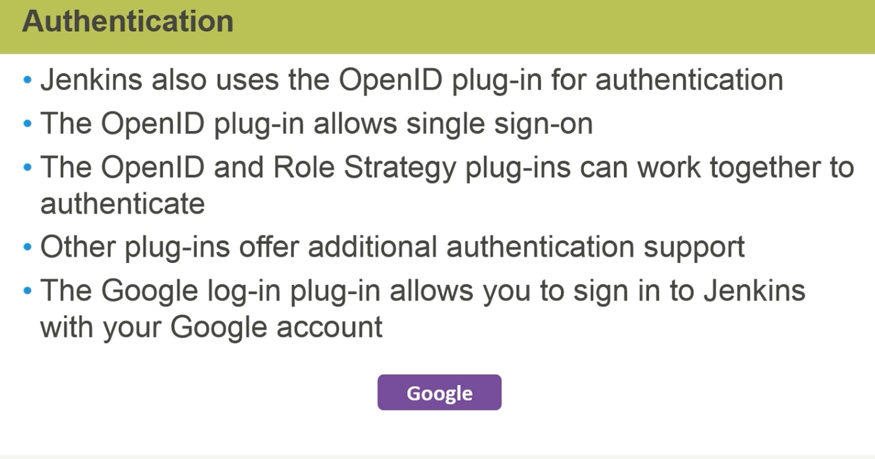

1. **Authorization:**

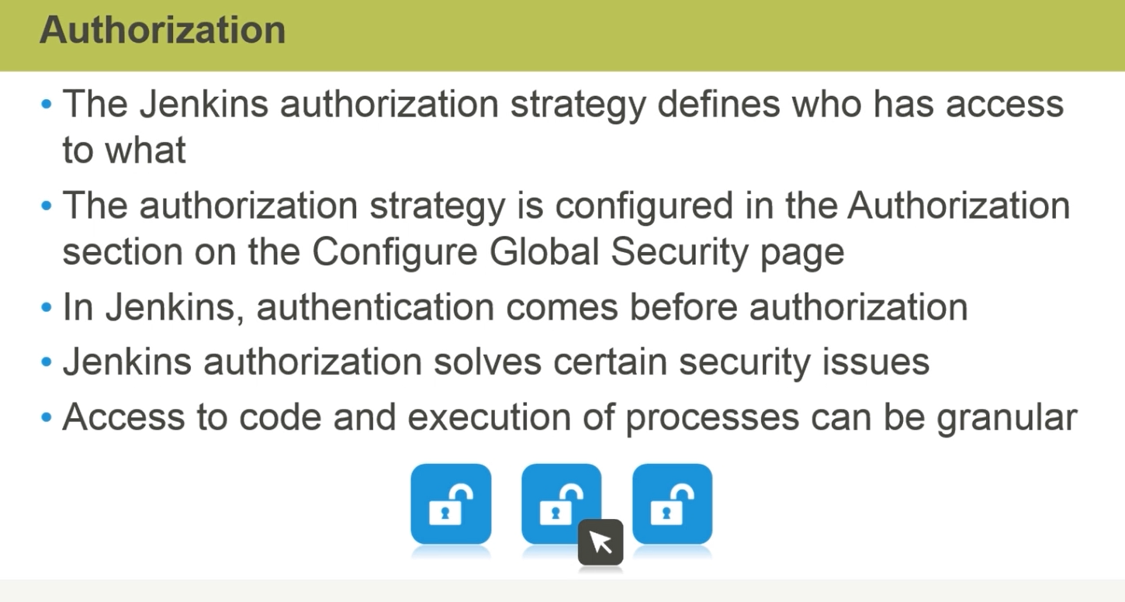

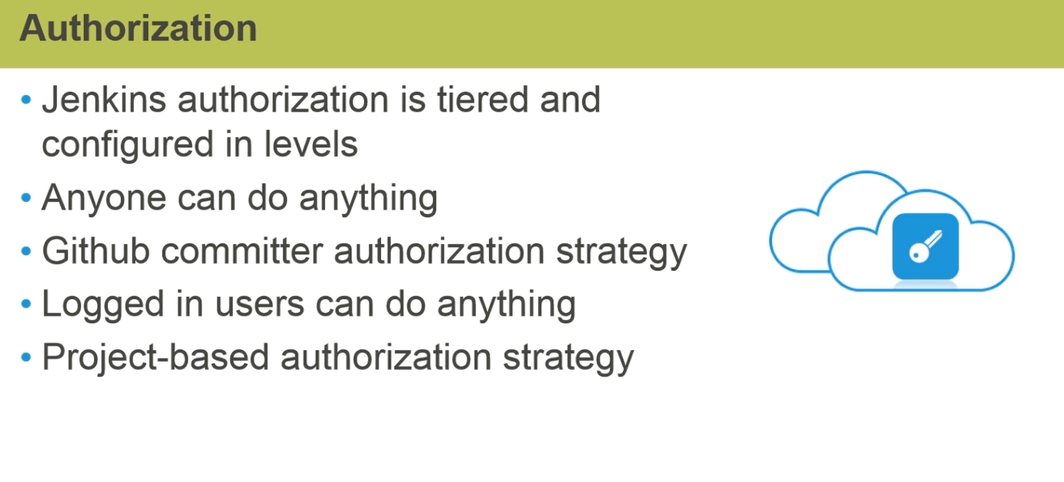

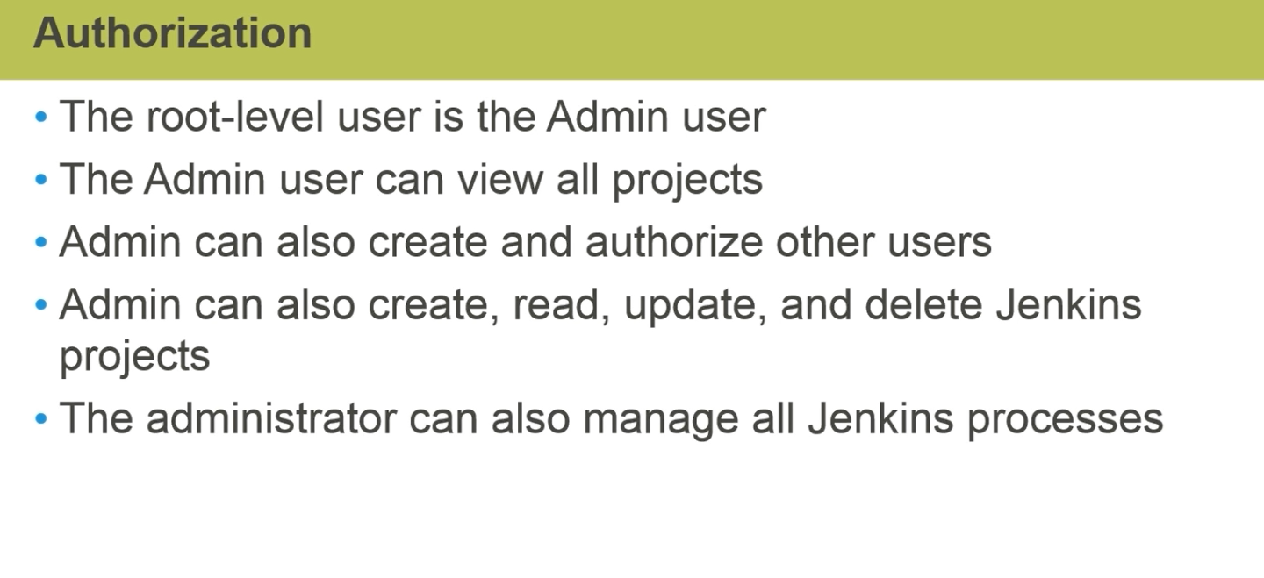

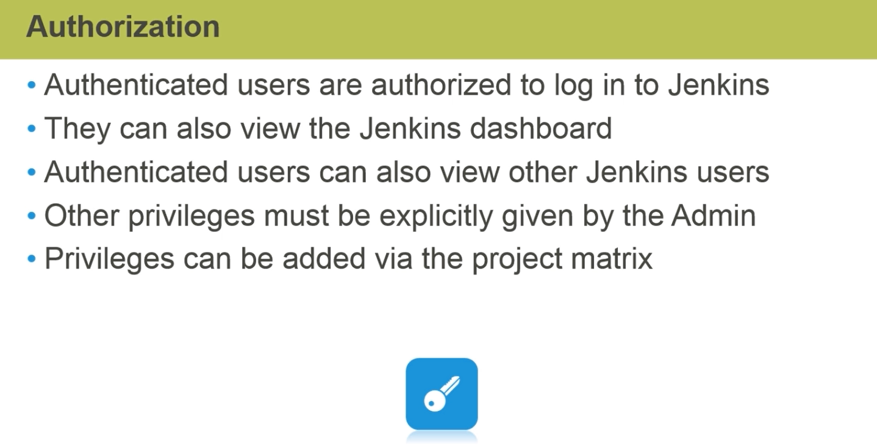

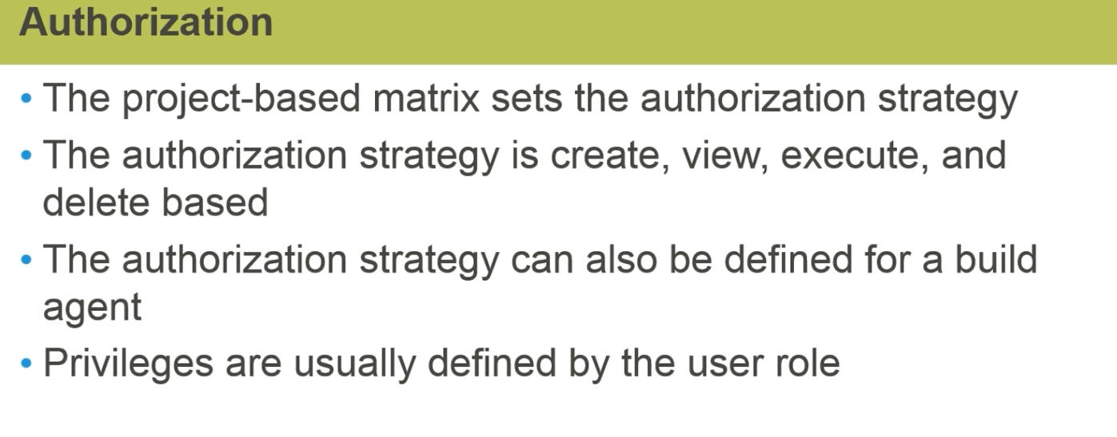

**Jenkins Run Options**

1. Running Jenkins as a standalone Application:
   1. Down load the .war file from internet
   2. Go to the folder where download is there.
   3. Run command “ **java -jar jekins.war**”
   4. In end you will get message “ Jenkins is fully up and running”
2. Running Jenkins on an Application server.
3. Installing Jenkins as a Windows service.
4. Non-java Options.

